## **Using List Methods**

Task:

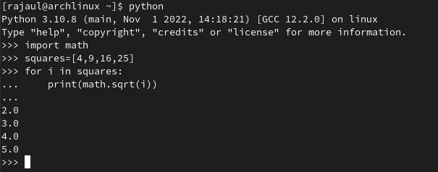

**Introducing Methods**

Task:

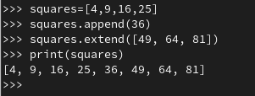

**The extend() Method**

Task:

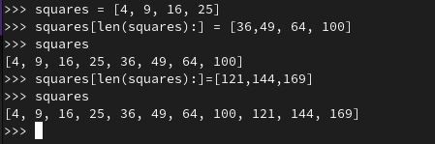

**The insert() method**

Task:

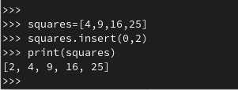

**The remove() method**

Task:

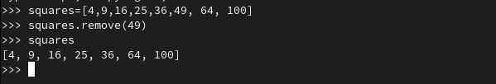

Task:

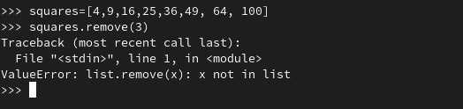

Task:

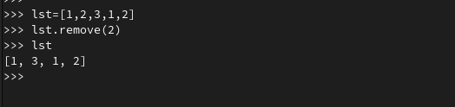

**The pop() Method**

Task:

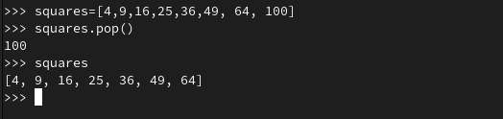

Task:

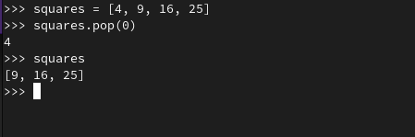

**The Clear() Method**

Task:

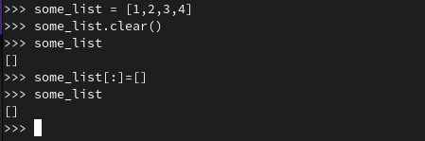

**The Sort() Method**

Task:

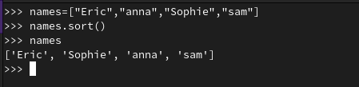

Task:

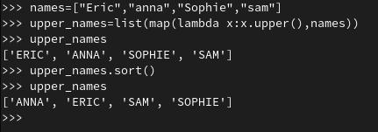

**The reverse() method**

TasK:

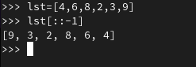

**The index(), count(), and copy(), methods**

Task:

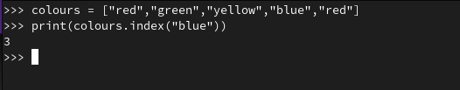

Task:

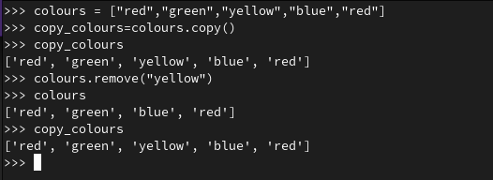

**The del Statement**

Task:

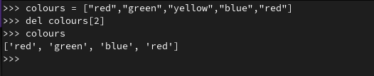

**List Comprehensions**

Task:

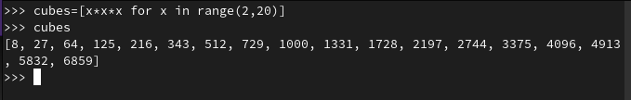

Task:

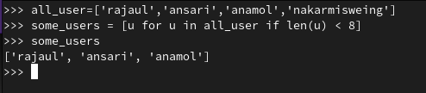

**Introduction to Tuples**

Task:

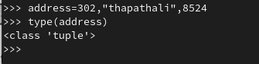

**Empty and Single element Tuples**

Task:

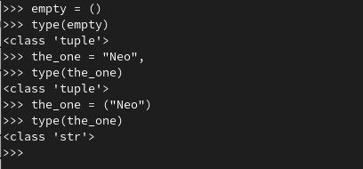

**Sequence Unpacking**

Task:

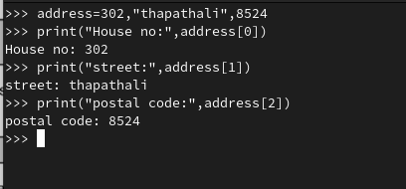

OR

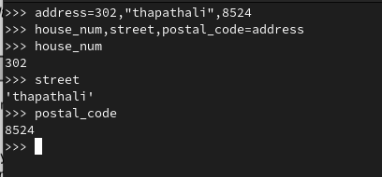

Task:

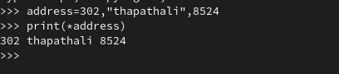

**Key Terminology**

**● Method** :Method is a class of an object.

**● List comprehension** :List comprehension is a short-cut way to create or define a list based on an existing list.

**● Tuple** :A tuple is a collection on multiple items in a single variable which is ordered and unchangeable

**● Tuple Packing** :Creating a Tuple with multiple elements is known as tuple packing.

**● Sequence Unpacking** :The process of accessing the elements/items of the tuple is called sequence unpacking.